Finding food…fast! Hands-on lesson on optimal foraging theory

PREPARATION
Summary
In this lesson, students will learn about the basics of optimal foraging theory – how animals find food – by engaging in a hands-on foraging activity. Through this activity they will (1) identify the key factors that affect foraging efficiency when food is clumped, (2) discover how each of those factors changes their own foraging efficiency, and (3) identify the relationship between foraging time and food density. In addition to participating in the hands-on component, each student will make observations and predictions, look for patterns, and make a graph of data that they collected. This lesson can easily be adapted for younger or older students.

Age
This lesson was written for middle school, but can be pared down for younger students or made more difficult for high school students.

Non-State & National Objectives
- Discover and explain the key factors that affect foraging efficiency
- Create predictions about how changing independent variables will affect dependent variables.
- Graph results from a foraging exercise
- Summarize results from experiment and design a new experiment based on findings
- Apply foraging theory to an animal in their back yard

State Science Objectives
- 8.L.3: Understand how organisms interact with and respond to the biotic and abiotic components of their environment.
  - 8.L.3.1: Explain how factors such as food, water, shelter, and space affect populations in an ecosystem.

Next Generation Science Objectives
- 4-LS1-2: Use a model to test interactions concerning the functioning of a natural system.
- MS-LS1-1: Use argument based on empirical evidence and scientific reasoning to support an explanation for how characteristic animal behaviors and specialized plant structures affect the probability of successful reproduction of animals and plants respectively.

Materials
- Chickpeas
- Sharpie/marker
- Spoons (or chopsticks for older students) – one for every pair of students
- Bowls – four for every pair of students
- 2 worksheets (see below) – one for every pair of students
- Stopwatch

Preparation
- Label the bowls 1, 2, 3, 4
- Put 1 cup chickpeas in each of the bowls, or use more if the bowls are shallow or students are older
- Draw a small black dot on 20 beans in each bowl
- Each bowl should be 10 meters away from the next (ie, bowls 1&3 can be next to each other, 10m away from bowls 2&4)

Foraging activity rules
- Students will have 4 minutes to forage for food (beans with dots) across the 4 bowls. They will pretend they are sparrows (or any other animal), foraging for their survival.
  - 30 chickpeas in 4 minutes: Just enough for the sparrows to eek by
  - 40 chickpeas in 4 minutes: Not going to be hungry!
  - 50 chickpeas in 4 minutes: Well done – you’re stocking up for winter!
- They need to collect food with a spoon. They cannot collect non-food items (beans without spots)
- While one student forages, their partner will time them, count the number of beans collected, and fill out their performance on the worksheet.
- After each student in the pair has foraged once, work as a class to generate the main factors that alter foraging efficiency (see # 6 below and lesson).
- Now or as an extension, students collect data and create a graph showing the pattern between time spent foraging and food collected
- Continue the 4-minute foraging bouts. Each time both students in the pair has had a foraging round, students will (1) return the beans to their bowls and (2) discuss what change they want to make for the next round and record their change. Encourage them to make a prediction about what will happen with each change. They can choose to make the change in the direction that facilitates food intake or in the direction that make it more difficult. Possible changes are:
  - Move bowls closer to or farther from each other (travel distance)
  - Use hands instead of spoon, or use spoon with non-dominant hand (handling or processing time)
  - Add food to or remove food from each bowl (food density)
  - Increase or decrease food quality (food value)
- Students will continue doing rounds until they have tried all 4 changes, or made up additional changes. They do not have to re-set to the original rules each time, but they can if they want to.

THE LESSON
Engage
Ask some or all of these questions. Students can discuss with each other, write down their thoughts in a notebook, or participate in a class discussion.

Question 1: Has anyone ever seen a bird (or squirrel, or monkey!) eating fruit from a tree? I have, and when the tree is really full of fruit, they look so wasteful! They take one bite out of every fruit, then drop it on the ground. Why do you think they do that?

Question 2: Has anyone ever been berry-picking? If so, what fruit, and did you have a strategy or plan for how to pick the most berries?

Question 3: What are some animals you see in your back yard or neighborhood? How do those animals – squirrels, chipmunks, songbirds, deer – find food? How much of the day do you think they spend finding food? How important do you think it is that they can find and eat food as quickly as possible? How do you think they do that?

Explore
Tell students: Foraging is a fancy word for finding food. You’re going to practice foraging like sparrows and see if you can get enough food to survive!

Facilitate 1st round of foraging activity (steps 1-4 or 1-5 of Foraging activity rules).

Explain
Gather students. What how many beans did people collect? What made that difficult? Write answers on the board, clumping answers by the foraging factors they match:
- Travel distance (eg, it takes a while to get from one bowl to the next)
  - Would your food intake change if bowls were closer or farther? Or if you had to crawl instead of run/walk? Would your time at each bowl change?
- Processing time (eg, it’s hard to collect with spoon)
  - Would your food intake change if you could use your hands, or if you had to use the spoon with your non-dominant hand?
- Food density (eg, it’s hard to find food in the bowls)
  - Would your food intake change if there were 40 food items in each bowl instead of 20? What if there were 10? Would you change your time at each bowl?
- Increase or decrease food quality
  - Would your food intake change if each food item was worth twice as much? Would you change your behavior?

Explore II
Facilitate students engaging with the remaining rounds of the foraging activity (steps 5-7 or 6-7 of Foraging activity rules).

Elaborate
Give pairs of students 5-10 minutes to look over their results and ask them to write down (1) their main findings from their foraging, (2) what they want to test next, and (3) how their findings might relate to the behavior of animals in their backyard (e.g., squirrels, songbirds, deer)

Bring students together to share their findings. Write each response on the board.

Extend
Ask students: How well do you think animals follow the rules, so they collect as much food as possible?
- Facilitate a discussion to discover that animals have evolved lots of different characteristics (adaptations) that help them survive and reproduce. Because food is one of the more important factors in survival and reproduction, you can bet that most animals have evolved to be very good at finding food fast!
- Encourage students to draw on their findings from their experiment today and any other information they have about animal behavior.
  - FYI, there are notable exceptions to this, due to big shifts in life history tradeoffs that have evolved in some animals. Sloths, for example, don’t eat a whole lot, but they make up or that low food intake by having a very slow existence.

At the end, or before Explore II: Students will identify the relationship between time spent foraging and food collected. (Optional: First, ask students what they think the relationship will look like. You can give them the empty plot and ask them to draw in their prediction and explain why.) In each pair, have them take turns. One student will hunt for all 20 food items. The other student will write down the time that each item is collected. After both students have gone, students will graph their results, either using the template below or drawing their own axes.

Ask students: Do you think this exercise is over-simplified? How? Encourage students to think of factors we left out – there are a lot! Examples include predation of foragers, other animals competing for similar food, weather, other food resources, how much time foragers need to do other essential things like find water and shelter. Draw a diagram on the board of links between the factors you identified in the main exercise, then have students add in their responses.

In a future class period, students can perform the future experiment they wrote down during the Elaborate section. One fun version of this would be to have one common food resource that is worth very little, and one rare food resource that is worth a lot. Students will have to decide which to spend their time looking for.

Resources
This lesson simplifies and slightly adapts theory from seminal work. The figures below are from Charnov 1976.
- Charnov, E. L. (1976). Optimal foraging, the marginal value theorem.
- Emlen, J. M. (1966). The role of time and energy in food preference. The American Naturalist, 100(916), 611-617.
- MacArthur, R. H., & Pianka, E. R. (1966). On optimal use of a patchy environment. The American Naturalist, 100(916), 603-609.
- Pyke, G. H., Pulliam, H. R., & Charnov, E. L. (1977). Optimal foraging: a selective review of theory and tests. The quarterly review of biology, 52(2), 137-154.
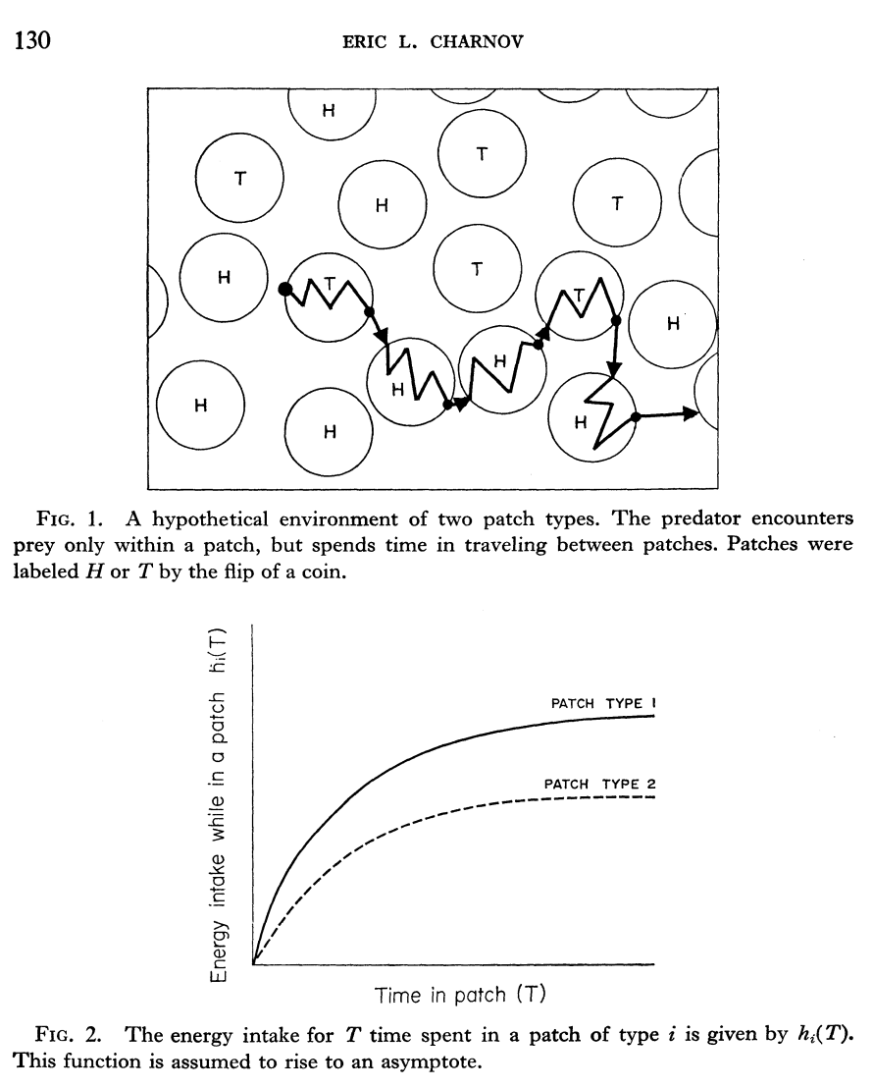

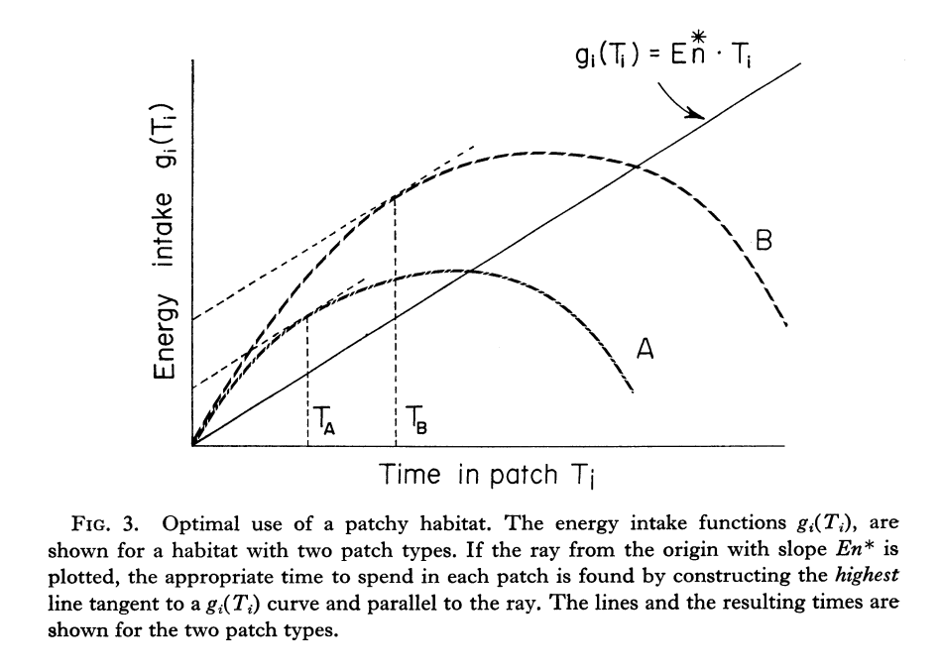
Worksheet for Finding Food Fast! Name:
Time spent foraging (minutes)
Total food items collected
50

40

30

20

10

0
0 1 2 3 4
1. Predict: Draw what you think the relationship between the amount of food collected and time will look like

Item # | Time collected | Item # | Time collected | Item # | Time collected
1 |  | 21 |  | 41
2 |  | 22 |  | 42
3 |  | 23 |  | 43
4 |  | 24 |  | 44
5 |  | 25 |  | 45
6 |  | 26 |  | 46
7 |  | 27 |  | 47
8 |  | 28 |  | 48
9 |  | 29 |  | 49
10 |  | 30 |  | 50
11 |  | 31 |  | 51
12 |  | 32 |  | 52
13 |  | 33 |  | 53
14 |  | 34 |  | 54
15 |  | 35 |  | 55
16 |  | 36 |  | 56
17 |  | 37 |  | 57
18 |  | 38 |  | 58
19 |  | 39 |  | 59
20 |  | 40 |  | 60

2. Collect data: Take turns. One person will forage for 4 minutes, trying to collect as much food as possible, while the other records the time that each item is collected.
30 food items: Just eeking by. 40 food items: Going to bed full. 50 food items: Good work – ready for winter!

3. Graph your results.

Time spent foraging (minutes)
Total food items collected
50

40

30

20

10

0
0 1 2 3 4
Worksheet for Finding Food Fast! Name:
Round | Condition | # food items collected | Observations & Experiment for Next Round | Prediction
1 | Control (normal)
2
3
4
5

